Labour Productivity
Labour productivity measures the amount of goods and services that a worker produces in a given amount of time. A business might take action to increase the productivity of its workforce in the following areas.

Management practice
Managers are the leaders of a business, response for responsible for coordinating employees and using capital resources to optimise profit. There is a clear link between the quality of managers and productivity. Research suggests that Australian managers need to devote more attention to their people management skills, Good people managers attract the right employees to their business, retain them and develop their talent. Good people managers also reward employees who perform well and do not allow poor performers to continue in their roles.

Training
Employees who develop better skills and knowledge are likely to improve labour productivity. Developing employee skills and knowledge may take place through attending training (either on or off the job; or participating in mobile learning using electronic devices such as computers, MP3 players, notebooks, mobile phones and tablets. Employees can also gain new skills and knowledge through job rotation, where an employee experiences what it is like to undertake different jobs within the business. They may also experience job redesign, where work responsibilities and tasks for particular jobs are changed, giving the employee the opportunity to gain broader employment experience. Mentoring programs, where a more experienced employee provides guidance and support to a less experienced employee, can also increase labour productivity. Secondment is another way to develop an employee and may involve an employee working in another organisation temporarily. Employees who develop their skills and knowledge may experience higher levels of job satisfaction, leading to reduced staff turnover (staff leaving the business) and absenteeism. Skilled staff are better able to serve customers and handle equipment required to do their job.

Workplace culture and flexibility
Each business has its own way of conducting business. A business" culture' is influenced by such things as values, beliefs, the vision for the business and habits. If an organisation is considered to be a good place to work, labour productivity is likely to be higher. A business might also improve productivity by providing employees with the support they need to do their job. Supporting the employee involves providing the right equipment to do the job and providing an appropriate work environment. Some businesses allow their employees to work offsite (such as working at home). In some cases this is thought to improve productivity as. it provides the employee with more flexibility. Less time is spent commuting and a quieter work environment may mean more work is completed.

Performance appraisal and feedback

Performance appraisal is an assessment or evaluation of how well an employee is performing in their job, based on criteria that have been predetermined by both the employee and employer. For example, a sales representative may have a monthly and annual target to sell a certain number of products or earn a certain amount of revenue for the business. Performance appraisal provides important feedback to the employee and makes them accountable to the business. It may assist in improving job performance, provided feedback is constructive and given on a regular basis.

Employee incentive schemes
Employees may be offered a financial incentive over and above their normal wage for meeting agreed performance targets. Incentives take many forms, such as cash bonuses, shares in the business or non-monetary rewards such as vacations or additional paid leave. The incentive is linked to performance and therefore can improve productivity in a business.

Capital productivity
Capital is used in the production of goods and services and includes such things as machinery, computers, mines, tools and buildings. Capital productivity measures the amount of goods and services that can be produced using a fixed amount of capital in a given amount of time. Businesses can improve capital productivity in a number of ways.

Technology
Businesses can increase their productivity by using equipment that uses the most advanced technology available in order to save time and cost.
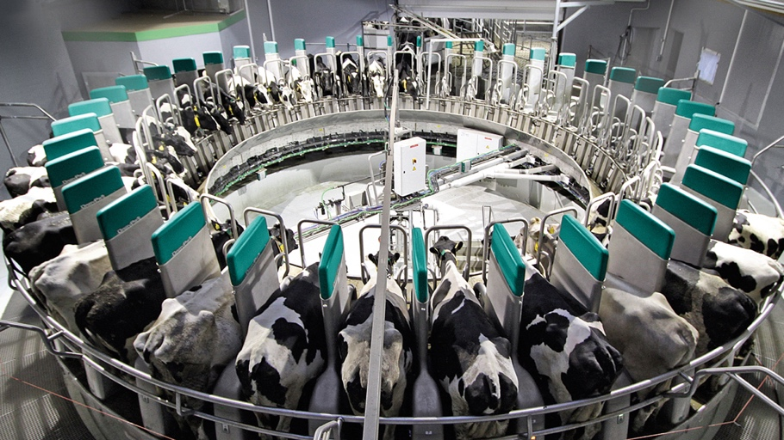
Improving processes
All businesses use a number of processes to produce a product (either a good or a service). A simple example of a process is taking an order at a restaurant. A waiter may take the order, using a pen and paper or a computer, or the customer may need to go to the counter to order. If customers provide feedback that it takes too long to order a meal, the owner must improve business processes. Certain processes are also used to produce goods. Some manufacturing businesses use just-in-time inventory systems so that materials arrive at the right time without the need to hold vast amounts of stock. This reduces storage costs and the possibility of waste or damage to stock.

The Margaret River Chocolate Company
The Margaret River Chocolate Company has been a business success, with the company first opening a factory in Margaret River in 1999 and then opening a second factory one year later. The first day of business took the owners by surprise when their estimated 200 customers turned out to be 2000. People love chocolate, and making a quality product and focusing on the customer has been key to productivity for the Margaret River Chocolate Company, Martin Black, co-owner of the company, talks about how his company has improved productivity. Fortunately, over the last few years we have grown our output and the choice of mid-range equipment has increased, so we have been able to increase productivity through mechanisation. We have also increased our number of outlets to give greater economies of scale, which also benefits productivity. You just have to ensure your people are valued, motivated and well-rewarded.


The company uses a range of strategies to improve productivity. Expanding the business has meant the company can produce a greater quantity of chocolate with lower per-unit costs and also has the capital to invest in more sophisticated equipment. Labour productivity strategies at the company include providing incentives and remuneration to senior managers and ensuring the company is a great place to work. Ensuring staff are properly trained is another way the company seeks to lift productivity.

ACTIVITIES
- List and outline 5 ways that labour productivity could be increased.

- Describe with an example, how labour resources can be used to increase productivity.

- Name two strategies the Margaret River Chocolate Factory used to improve productivity.

- Suggest how the following businesses could improve their productivity:
- Antoinette owns and runs a bakery. Her product is the best there is but customers have to queue for a long time to be served.
- Joel owns his own hairdressing business and is the only worker. He does everything from making the coffee to answering the phone. He regularly runs late and his customers complain about this.
- Deb runs her own accountancy practice. She has two accountants working for her but can't keep up with customer demand around tax time.
- Aaral is a busy and successful restauranteur, she recently hired extra waiting staff but noticed how rude they are to customers.
- Tom runs a mowing business but when he is mowing lawns, he does not answer the phone and loses potential customers.
- Jack is the Chief Executive Officer (CEO) of a large firm. He arrives early and leaves late and can be heard shouting at everyone when he is under stress.

- Look at the way you study at school and at home. Write down your study habits, taking into consideration such things as when and where you study, why you study, how you try to remember facts, and any aids you use. How could you improve the processes you use to study?

